Report 1 Final Version
Pool Control System

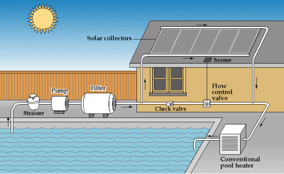
by Unknown Author is licensed under

Team BST – Members:
Steven Rioux
Taft Barrott
Brenton Dube

Table of Contents:
Part 1:
Page 3: Customer Statement of Requirements
p3: Overview
p4: The Basics
Page 7: System Requirements
p7: Functional System Requirements
p8: Nonfunctional System Requirements
p10: On-Screen Appearance
Part 2:
Page 13: Functional Requirements Specification
p13: Stakeholders
p14: Actors and Goals
p15: Use Cases Casual Description
p16: Use Case Diagram
p17: Traceability Matrix
p19: Fully-Dressed Description
p22: System Sequence Diagram
Page 20: User Interface Specification
p20: Preliminary Design
p23: User Effort Estimation

Part 1 Contributions:
Steve: Customer Statement of Requirements and System Requirements.
Taft: Customer Statement of Requirements, System Requirements.
Brenton: Table of Contents, Customer Statement of Requirements final editing, System Requirements overview edit.
Part 2 Contributions: (according to Brenton)
Steve: Contributed to both parts with previous documentation notes needed for Part 2.
Taft: Wrote most/all of the Functional Requirements Specification and contributed with previous notes.
Brenton: Brenton's self estimate is that he did 10-25% of the Part 2 work. Worked on: Table of Contents, Git and Github organizing files, added User Effort Estimation and Preliminary Design sketches to User Interface Specification, edited Functional Requirements Use Cases.
Final Draft Report 1 contributions: (written by Brenton)
Taft: Added the entirety of the sections: Use-Case Diagram, Traceability Matrix, Fully-Dressed Description, System Sequence Diagram.
Brenton: Added three use cases to the fully-dressed descriptions. Very minor corrections such as spelling errors.
Customer Statement of Requirements
Overview
If you have a pool, would you like to control and monitor it with a computer. There are many people that own a pool, and almost everyone leaves the residence on which the pool is located for one reason or another. For some people it is a vacation home and they are gone more often than they are there. Do you want to raise and lower the temperature of the pool? How will you know if your pool is working so that it can be enjoyed upon returning? There are a lot of things that could go wrong. Equipment failure or a clog could happen at any time, without notice unless there's a mechanism to report problems.
The problem is there is no way to monitor your pool while you are away unless you hire someone to come check it for you. That would be very expensive or bothersome to a neighbor if he is kind enough to check it. There is also the competence factor. There is no telling how much your neighbor even knows about pool. It would be a lot cheaper and easier to just check it yourself online. That is why there is a system designed to monitor different components of your pool.
There are many individual components that make up the complete pool system. The pool system is a closed loop system with the most important part being the pool pump motor which draws pool water from the pool and forces it through the filter and other system components and back into the pool. This system must include a solar heating system control, pool motor starter, and pressure monitoring system. With a graphical user display that is easy to use and intuitive.

The Basics
The basic components of the system shall be:
Inputs:
- T1 – Temperature sensor 1 (temperature of the pool water)
- T2 – Temperature sensor 2 (Temperature of the roof)
- P1 – Pressure Sensor 1
Outputs:
- M1 – Motor contactor 1 for the main pump
- V1 – Valve 1, for Solar Heat
- V2 – For by pass
The system shall operate as follows, the user is allowed to enter the following Values on the graphical user display:
- Pump Start Time
- Pump Stop Time
- Target Pool Temperature
- Max Pressure
- Min Pressure
- Bypass Valve Enable
Detail
A security measure will prevent unauthorized access to the system. The user will be able to operate the system with any web browser internet connection. The control system's connection to a web server enables communication with the user. There will be an administrator that will create a username and password for the user to securely access the website. From the website you will see the following: the temperature of the water in the pool, the set temperature that you would like the water to reach, the temperature on the roof where the solar panels are located, an on/off switch to enable pool heating, the pressure of the water in the tubing of the filtering system, the minimum and maximum pressures allowed by the system, the start and stop times for the pump, and the valves’ statuses (open or closed).
There will be controls to change the target temperature. This is the temperature to which the pool will heat up. The solar heating is based on several factors. When it is enabled on the user display, the control system shall monitor pool temperature and roof temperature. If the pool temperature is below the “Target Pool Temperature” and the roof temperature is at least 20 degrees above the pool temperature, then V2 should be enabled and the pool water shall be directed through the solar heating panels.
There will also be controls to change the minimum and maximum pressures allowed in the system to prevent damage to the pump, filter, and other parts of the system. Any time the pool pump is running the pressure should always be monitored. If the pressure is detected to be greater than the “Max Pressure”, it shall immediately shut the pump down and display a warning on the display. This warning shall be reset by the user only while the pump is off. The minimum pressure is active two minutes after the pump has been turned on. If at any point passed the two minutes the pressure is below the “Min Pressure” setpoint, the system should immediately shut down and display a warning. This would indicate a possible leak in the system.
There will also be controls for the start and stop times for the pump. The Pool Control shall turn the pump M1 on at the “Pump Start Time” and turn it off at the “Pump Stop Time”. These can be programmed for any time of the day. Every day that the system is turned to on, the pump will start at the given time and stop at the given time. There will be multiple stop and start times available if more than once a day is required. If all of the pump start times and pump stop times are deleted, then the system will not turn on automatically. A warning message should display saying that no automatic pump times have been added.
There are two valves that are used in the heating system. The valves are two position. Valve 1 is used as a bypass valve that will divert the water from the filter to the second valve when off and from the filter directly to the pool when on. The second valve V2 will direct the water from Valve 1 to the solar heating when enabled or through the regular return path. The bypass valve V1 shall always be in the off position unless it is selected on from the graphical user interface, if the bypass valve is on, V2 shall immediately be disabled and all heating functions shall be disabled.

System Requirements
The main controller system shall be a microprocessor that has Wi-Fi capability. It should have an open source firmware to allow easy adaption and future upgrades. A graphical user interface shall also be included with the design along with easy to use functions. The controller should be able to be connected to through either a local area network or the internet. The system should have a web application running the user interface. The web server should know the system state by calling the appropriate functions, such as the water temperature for example.
Functional System Requirements
Identifier | PW | Requirement
REQ 1 | 5 | The system shall obtain pool water temperature
REQ 2 | 4 | The system shall obtain roof temperature
REQ 3 | 5 | The system shall obtain water pressure
REQ 4 | 5 | The system shall obtain pump status (on/off)
REQ 5 | 5 | The system shall obtain valve 1 status (open/closed)
REQ 6 | 5 | The system shall obtain valve 2 status (open/closed)
REQ 7 | 4 | The system shall obtain heater status (on/off)
REQ 8 | 2 | The system should allow adding users and passwords
REQ 9 | 2 | The system should allow removing users and passwords
REQ 10 | 4 | The system should allow changing target temperature
REQ 11 | 4 | The system should allow changing the start pump time
REQ 12 | 4 | The system should allow changing the stop pump time
REQ 13 | 3 | The system should allow adding a start pump time
REQ 14 | 3 | The system should allow adding a stop pump time
REQ 15 | 3 | The system should allow deleting a start pump time
REQ 16 | 3 | The system should allow deleting a stop pump time
REQ 17 | 5 | The system shall have the ability to start the pump
REQ 18 | 5 | The system shall have the ability to stop the pump
REQ 19 | 5 | The system shall have the ability to open valve 1
REQ 20 | 5 | The system shall have the ability to open valve 2
REQ 21 | 5 | The system shall have the ability to close valve 1
REQ 22 | 5 | The system shall have the ability to close valve 2
REQ 23 | 4 | The system should have the ability to turn on the heater
REQ 24 | 4 | The system should have the ability to turn off the heater
REQ 25 | 3 | The system should have the ability to change the maximum pressure
REQ 26 | 3 | The system should have the ability to change the minimum pressure
REQ 27 | 5 | The system shall have the ability to compare the maximum pressure to the actual pressure
REQ 28 | 5 | The system shall have the ability to compare the minimum pressure to the actual pressure
REQ 29 | 4 | The system should have the ability to compare the target temperature to the pool water temperature
REQ 30 | 4 | The system should have the ability to compare the roof temperature to the pool water temperature
REQ 31 | 2 | The system should display a warning sign on the user interface if a component reads out of scope.

Nonfunctional System Requirements
Functionality:
- The system should authenticate the user by matching the username and password.
- The system should not allow any other users besides the administrator.
Usability:
- The system should be able to monitor the system components regularly and accurately, updating changes to the website
- The user interface should be simple and easy to read.
Reliability:
- The system should be able to reboot after failure within a minute.
- The system should be able to run smoothly provided there is no interruption with the internet service.
Performance:
- The system should be able to open and close valves or turn the system or heat on and off within a couple seconds.
Support-ability:
- The system should be easily tested by getting on the website while at the pool by watching and listening after buttons are pushed on the user interface.
- Configuring the system to the appropriate settings is a personal option that is easy to do on the website. The only concern would be getting useful minimum and maximum pressures on the system.

On-Screen Appearance
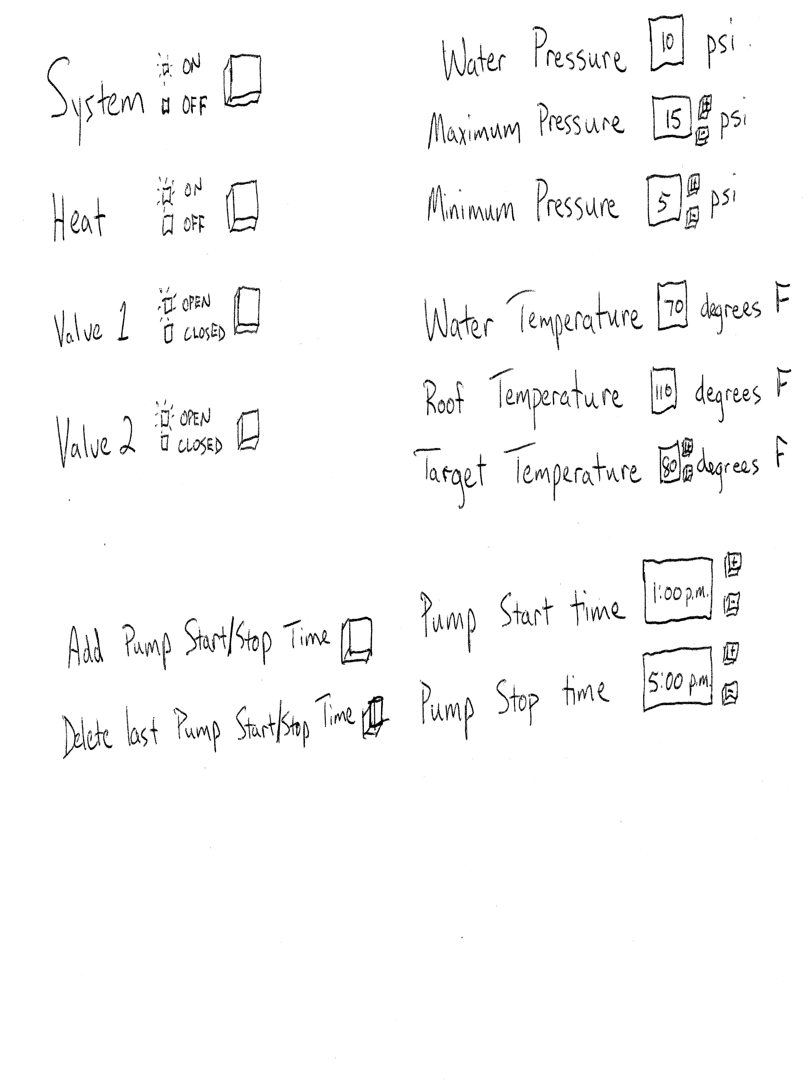
This user interface is a simple design. The system has a button to push and lights to indicate whether the system is on or off. The heater is the same with a button and lights to indicate on and off. Valves one and two also have a button and light indicators for closed and open. The water pressure in a readout obtained from the system and automatically update. The maximum and minimum pressures can be adjusted with the + and - buttons beside it. The water temperature and roof temperature are readouts obtained from the system and automatically update. The target temperature is the temperature the user would like the pool water to be and is adjustable by the + and - buttons beside it. The pump start time and pump stop time are adjustable in 15 minute increments by the + and - buttons next to them. There are also buttons to add another start and stop times and to delete the last start and stop times. There will be additional space at the bottom of the user interface to add more start/stop times. It is possible to delete all the start and stop times. In this case there will not be an automatic system cycle. There will also be a spot at the top of the screen for warning messages from system abnormalities.

Functional Requirements Specification
Stakeholders
- Pool owners
- Raspberry Pi Foundation
- Pool pump manufacturers
- Pool stores
- Solar companies
The pool owners would be most interested in this. They would be the ones that benefit from this product becoming a reality. Since we are going to use a Raspberry Pi, they would benefit from any sales that result from it. A Raspberry Pi is a small computer that looks like a large computer chip. It has ports like a computer and is used to interface between mechanical and electrical. That is, it takes a program from the computer and interacts with objects. The publicity from it to use these devices in other applications could also be beneficial to them. Pool pump manufacturers could benefit from this. The could design pumps that are easier to interact with by programmable means. This would raise the sells of that company. Pool stores would be in a similar boat. By buying the most useful pumps that are applicable and make them a selling point when they sell a pool to add on the pump. Solar companies would benefit from it as well. We are connecting a solar heating apparatus that will heat the pool. This is more efficient than electrical or gas heating. This will entice people to buy solar panels to heat their pools. Also, the solar companies that retail the panels will have an increase in sales.

Actors and Goals
Actor | Goal
Administrator | To allow or deny access to a website for remote control
Pool Owner | To change the settings of the pool
Control | To apply the pool settings to the physical components
Control | To automatically turn of the pump if the water pressure is out of scope
Pool Pump | To turn on and off, allowing water flow
Heater | To turn on and off, allowing water temperature to rise
Valve 1 | To direct the flow of water to the solar heater
Valve 2 | To direct the flow of water to the solar heater
Website | To display the information from the pool components
Pool Components | To give information to Control

Casual Description
Use Case 1: LoadSettings
The administrator loads a previously saved set of settings. Included is a default settings file.

Use Case 2: SaveSettings
The administrator saves the current settings to a file.

Use Case 3: ChangeSettings
The administrator will access the website to change settings. The following are settings that can be changed: heater on/off, pump on/off, valve1 open/closed, valve2 open/closed, add pump time, delete pump time, change pump start time, change pump stop time, change target temperature, change maximum pressure, change minimum pressure.

Use Case 4: ApplySettings
The Control will take the settings from the user on the website and make the devices do what they are supposed to.

Use Case 5: AutoShutoff
The Control will automatically shut the pump off if the pressure drops below the minimum pressure or goes above the maximum pressure.

Use Case 6: AutoPump
The Control will automatically turn the pump on at the start time and turn the pump off at the stop time every day.

Use Case 7: HeaterControl
The Control will enable Valve 2 for water to flow to the solar heating panels under the following conditions: the pool temperature is below the “Target Pool Temperature”, the roof temperature is at least 20 degrees above the pool temperature, and the heater is turned on.

Use Case 8: DisplayInfo
The Control will take the information from the devices and output them to a display on the website.

Use Case Diagram
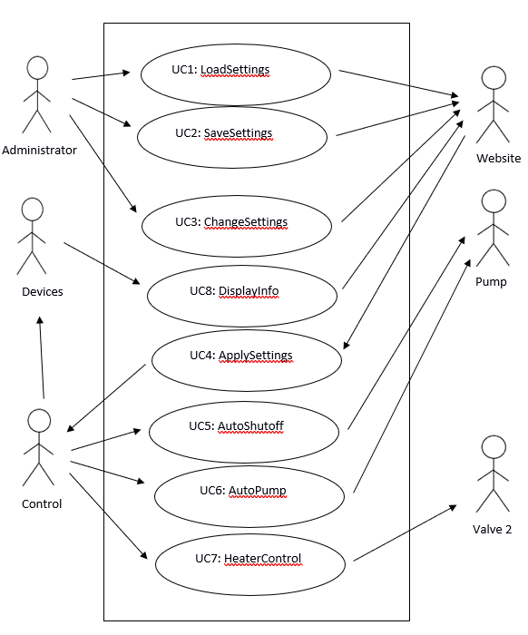

Traceability Matrix
 | PW | UC-1 | UC-2 | UC-3 | UC-4 | UC-5 | UC-6 | UC-7 | UC-8
REQ 1 | 5 |  |  |  |  |  |  | X | X
REQ 2 | 4 |  |  |  |  |  |  | X | X
REQ 3 | 5 |  |  |  |  | X |  |  | X
REQ 4 | 5 |  |  |  |  |  |  | X | X
REQ 5 | 5 |  |  |  |  |  |  | X | X
REQ 6 | 5 |  |  |  |  |  |  | X | X
REQ 7 | 4 |  |  |  |  |  |  | X | X
REQ 8 | 2 | X | X
REQ 9 | 2 | X | X
REQ 10 | 4 | X | X | X
REQ 11 | 4 | X | X | X | X
REQ 12 | 4 | X | X | X | X
REQ 13 | 3 |  |  | X
REQ 14 | 3 |  |  | X
REQ 15 | 3 |  |  | X
REQ 16 | 3 |  |  | X
REQ 17 | 5 |  |  | X | X |  | X
REQ 18 | 5 |  |  | X | X | X | X
REQ 19 | 5 |  |  | X | X |  |  | X
REQ 20 | 5 |  |  | X | X |  |  | X
REQ 21 | 5 |  |  | X | X |  |  | X
REQ 22 | 5 |  |  | X | X |  |  | X
REQ 23 | 4 |  |  | X | X
REQ 24 | 4 |  |  | X | X
REQ 25 | 3 |  |  | X
REQ 26 | 3 |  |  | X
REQ 27 | 5 |  |  |  |  | X
REQ 28 | 5 |  |  |  |  | X
REQ 29 | 4 |  |  |  |  |  |  | X
REQ 30 | 4 |  |  |  |  |  |  | X
REQ 31 | 2 |  |  |  |  |  |  |  | X
 |  | 4 | 4 | 5 | 5 | 5 | 5 | 5 | 5
 |  | 16 | 16 | 78 | 56 | 35 | 10 | 56 | 35

Fully-Dressed Description

Use Case UC-3: | ChangeSettings
Related Requirements:  Initiating Actor:  Actor’s Goal:  Participating Actors:  Preconditions:  Postconditions: | REQ 10 – REQ 26  Administrator  Change settings on the website for the pump  Website, Administrator, Control  Initial settings are in place, website is accessible  Changed settings will be relayed to control and take effect
Flow of Events for Main Success Scenario:
→ 1. Administrator accesses the website.
2. Administrator changes any desired settings.
← 3. The system displays the settings on the website.
← 4. The system sends the settings to Control to be applied.

Use Case UC-1: | LoadSettings
Related Requirements:  Initiating Actor:  Actor’s Goal:  Participating Actors:  Preconditions:  Postconditions: | REQ 8 – REQ 12  Website/Administrator  To load a set of settings for current use.  Website, Administrator  Connected to the website while a stored previously saved settings file is available for access.  The current settings are replaced with the settings from the chosen file.
Flow of Events for Main Success Scenario:
→ 1. The administrator requests a load of settings.
2. The administrator chooses a load file.
← 3. Control updates the displayed settings with the settings listed in the load file.

Use Case UC-2: | SaveSettings
Related Requirements:  Initiating Actor:  Actor’s Goal:  Participating Actors:  Preconditions:  Postconditions: | REQ 8 – REQ 12  Website/Administrator  To save a set of settings for potential future use.  Website, Administrator  Connected to the website and current settings are displayed.  The current settings are recorded to storage either on the user’s device or on the website server.
Flow of Events for Main Success Scenario:
→ 1. The administrator requests a save of settings.
2. The administrator chooses a save filename.
← 3. Control stores the settings to the chosen file name and location.

Use Case UC-4: | ApplySettings
Related Requirements:  Initiating Actor:  Actor’s Goal:  Participating Actors:  Preconditions:  Postconditions: | REQ 11, REQ 12, REQ 17 – REQ 24  Website/Administrator  To take the settings and put them into practical use  Website, Administrator, Pump, Devices  Connection to the website and it’s setting and the pump and other devices.  The pump and devices need to be controlled by Control turning on/off and opening/closing.
Flow of Events for Main Success Scenario:
→ 1. The system sends Control information from the website as input by the administrator.
← 2. Control changes the device according to the setting input by the administrator.

Use Case UC-5: | AutoShutoff
Related Requirements:  Initiating Actor:  Actor’s Goal:  Participating Actors:  Preconditions:  Postconditions: | REQ 3, REQ 18, REQ 27, REQ 28  Control  Shut the pump off if the water pressure is higher or lower than desired.  Control, Pump, Devices, Website  The minimum and maximum pressures have to be input. Control must be connected and allowed to change the devices  The pump is shut off if the pressure is not in the specified range.
Flow of Events for Main Success Scenario:
→ 1. Pump is turned on by Control.
- 2. The system checks the pressure periodically.
3. The system compares the pressure to the minimum and maximum pressures from the website.
← 4. The pressure is not between the minimum and maximum pressures and the system shuts Pump off.
← 5. Error message is sent to Website.
Flow of Events for Extensions (Alternate Scenarios):
→ 1. Pump is turned on by Control.
- 2. The system checks the pressure periodically.
3. The system compares the pressure to the minimum and maximum pressures from the website.
← 4. Control shuts off Pump through Control stop pump time or through Administrator on the website.

Use Case UC-7: | HeaterControl
Related Requirements:  Initiating Actor:  Actor’s Goal:  Participating Actors:  Preconditions:  Postconditions: | REQ 1, REQ 2, REQ 4 – REQ 7, REQ 19 – REQ 22, REQ 29, REQ 30  Control  Allow the water to flow to the solar heater under given conditions to heat the pool water.  Control, Valve 2, Pump  The pump must be turned on. The heater must be turned on. The control needs to be connected to the devices.  The pump opens Valve 2 and water flows to the solar heater.
Flow of Events for Main Success Scenario:
→ 1. Pump is turned on by Control.
2. The system checks if the heater is set to on.
- 3. The system checks the water temperature and compares it to the roof temperature.
← 4. The roof temperature is 20 degree or more than the water temperature, Control opens Valve 2 and water flows into the solar heating panels.
- 5. The system checks the water temperature and compares it to the target temperature.
6. The system checks the water temperature and compares it to the roof temperature.
→ 7. The target temperature equals the water temperature, and Control closes Valve 2.
Flow of Events for Extensions (Alternate Scenarios):
→ 1. Pump is turned on by Control.
2. The system checks if the heater is set to on.
- 3. The system checks the water temperature and compares it to the roof temperature.
← 4. The roof temperature is 20 degree or more than the water temperature, Control opens Valve 2 and water flows into the solar heating panels.
- 5. The system checks the water temperature and compares it to the target temperature.
6. The system checks the water temperature and compares it to the roof temperature.
← 7. Control shuts off Pump, and Control closes Valve 2. The water temperature never equals the target temperature.
Flow of Events for Extensions (Alternate Scenarios):
→ 1. Pump is turned on by Control.
2. The system checks if the heater is set to on.
- 3. The system checks the water temperature and compares it to the roof temperature.
← 4. The roof temperature is 20 degree or more than the water temperature, Control opens Valve 2 and water flows into the solar heating panels.
- 5. The system checks the water temperature and compares it to the target temperature.
6. The system checks the water temperature and compares it to the roof temperature.
← 7. The roof temperature is less than 20 degrees more than the water temperature. Control closes Valve 2.
Flow of Events for Extensions (Alternate Scenarios):
→ 1. Pump is turned on by Control.
2. The system checks if the heater is turned on.
- 3. The system checks the water temperature and compares it to the roof temperature.
← 7. Control shuts off Pump. The roof temperature is never 20 degrees or more than the water temperature.

Use Case UC-8: | DisplayInfo
Related Requirements:  Initiating Actor:  Actor’s Goal:  Participating Actors:  Preconditions:  Postconditions: | REQ 1 – REQ 7, REQ 31  Website/Administrator  To view, edit, save, or load the controller settings.  Website, Administrator, Control  Administrator logged into the website.  The current settings in use by the controller are displayed on the screen, along with options to change the settings, load a settings file, save a settings file, and apply any changes to the controller.
Flow of Events for Main Success Scenario:
→ 1. The administrator logs in to the website.
← 2. Control sends current state to the website.
3. Website displays current state.

Use Case UC-6: | AutoPump
Related Requirements:  Initiating Actor:  Actor’s Goal:  Participating Actors:  Preconditions:  Postconditions: | REQ 17, REQ 18  Control  To turn the pump on and off at the specified times.  Control, Pump  The pump must be turned on. The control needs to be connected to the pump.  The pump turns on and then off at the time the controller intended.
Flow of Events for Main Success Scenario:
→ 1. The controller turns the pump on at a particular time.
← 2. The controller turns the pump back off at a particular time.

System Sequence Diagram
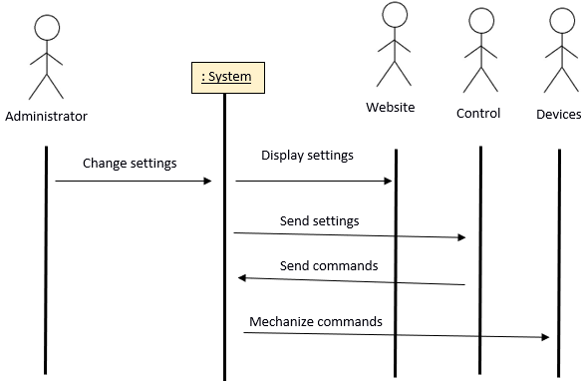

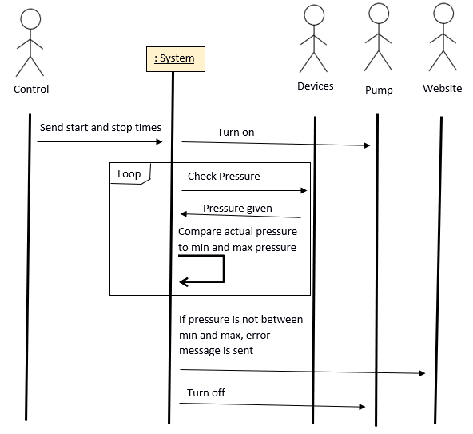
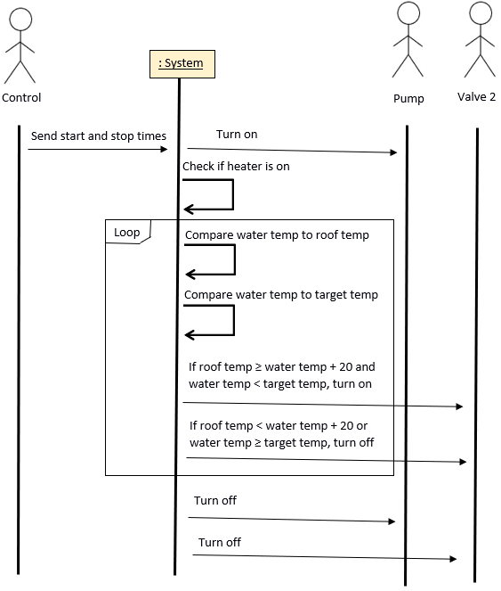
User Interface Specification
Preliminary Design
The system is accessed by loading the appropriate website address in the web browser. This will open a login screen containing a prompt to enter the one administrator username and password, with a submit button:
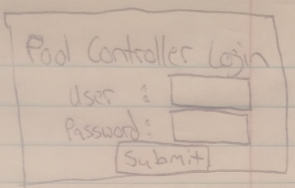

If the input is correct, the controller main page will appear. The following sketch shows how there will be three buttons at the bottom of the page. The user can load a previously saved settings file, save the current settings to file, or click update settings to tell the controller to use the currently shown settings. When a setting is modified, text will be shown warning the user that unsaved changes have been made, until the "Update settings" button has been clicked:
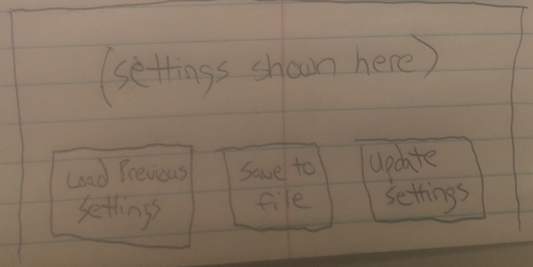

If "Load Previous Settings" is chosen, a pop-up window will allow the user to select a previously saved settings file. An additional functionality may be added to save and load settings files stored on the server itself rather than the user's current device. The load file selector may look like the following sketch:
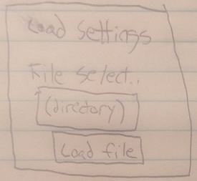

Similarly, "Save to File" then prompts the user how to save the current settings by chosing the directory and file name for storage:
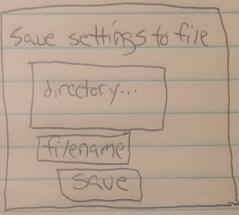

The main page should contain all of the settings and other information above the save/load/apply buttons. To activate or turn off the auto-shutoff feature, there's a button that can be clicked. Underneath it is shown the current water pressure as well as settings for the minimum and maximum allowed pressure. For both minimum and maximum pressure, the user can type in a changed degree number or click a button to raise or lower each number incrementally:

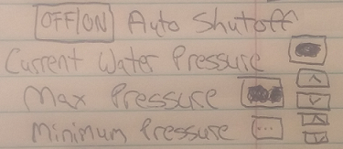

Very similar to the auto-shutoff functionality is the heater control. The control can be turned on or off, and the target temperature is shown and can be altered:
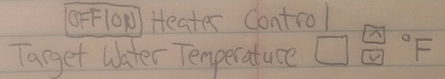

Existing pump timers are displayed on this main page as well. Each set of on/off cycle timings includes a "delete" button to remove that particular on/off cycle:
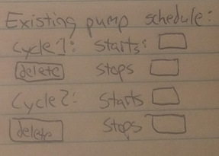

A new cycle can also be added to the schedule of pump cycles. This involves entering a start time, stop time, and clicking the "Add Pump time" button to add this cycle to the current list:
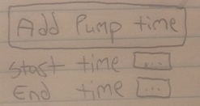

These feature sketches will all be displayed together on the same main page of the controller display website.
User Effort Estimation
To view or change any information, the user must first load the website. The number of inputs needed to load the website may vary. Then the username and password text box fields need to be filled out, and the Submit button clicked on.
After acting on the three inputs of username, password, and Submit login information, the controller information is displayed along with all of the options.
To load or save previous settings, the appropriate button needs to be clicked, then the file name selected from the directory selection pop-up window. This would involve a total of 3 clicks at minimum to choose "Load saved settings" button, select the appropriate settings file, and click "load file".
To turn the auto shutoff on or off or to turn the heater controller on or off requires two clicks by clicking the On/Off selector and the "Update settings" button at the bottom to save the change to the controller.
Changing the target temperature or pressures involves selecting the temperature field, typing the wanted temperature, and clicking "Update settings". When including the login screen, this would consist of interacting with five total buttons or text boxes.
To add a pump time, input a time into the start and stop fields, click "Add Pump Time", and then "Update settings".

